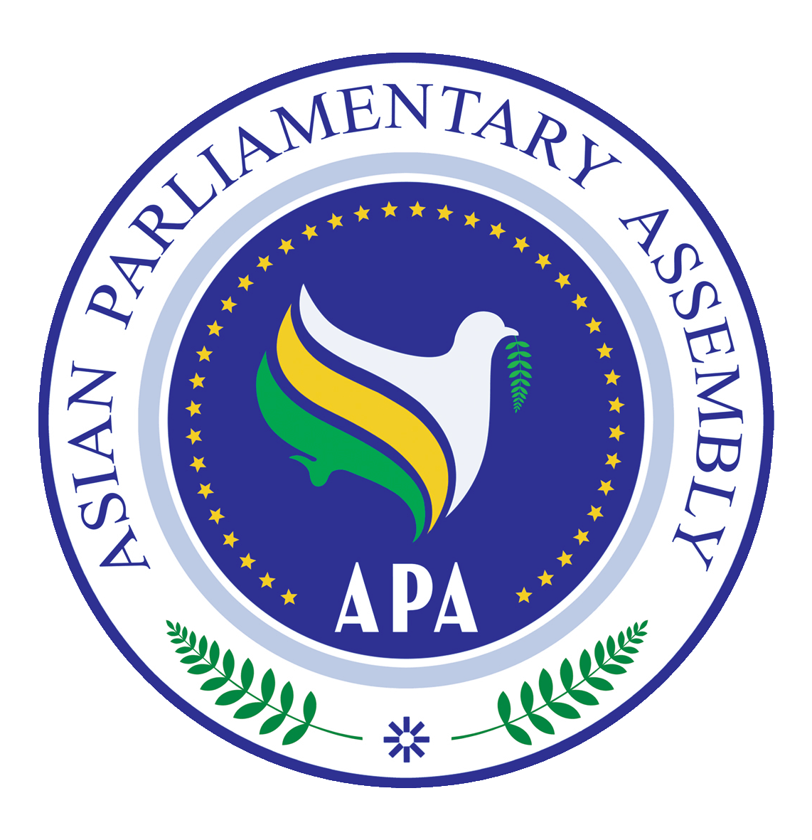 | Asian Parliamentary Assembly |  | EC1/SC-Political/Draft Res/2023/01  28 November 2023  Turkiye

Draft Resolution on Asian Parliaments’ Unwavering Support for the Palestinian People
We, the Members of the Asian Parliamentary Assembly,
Recalling APA Resolutions on Supporting Palestinian State and Protecting Rights of Palestinian People, (APA/Res/2013/03, 9 December 2013); Violations of International Humanitarian Law in the Palestine and the War Crimes Committed By the Zionist entity in Gaza (APA/Res/2009/01, 8 December 2009); and Humanitarian Crisis in Palestine Particularly in the Gaza Strip (APA/Res/2008/08, 29 November 2008); the catastrophic humanitarian impact of the aggressive war on the Gaza Strip in July 2014. and Zionist entity indiscriminate bombardment on the Gaza Strip since 7 October 2023 which deliberately targeting the civilians including women and minors;

Also recalling the resolutions of the United Nations Security Council, including resolutions 242 (1967), 252 (1968), 267 (1969), 298 (1971), 446 (1979), 465, 474, 478 (1980), 468 (1980) and 1322 (2000), 2334 (2016), and resolutions of the United Nations General Assembly and other relevant international documents.

Inspired by the Principles and objectives enshrined in the APA Charter and the relevant APA resolutions;
Committed to contribute to the promotion of peace and security at regional and global levels on the basis of justice and the rule of law;
Affirming the responsibility of the international community to support implementation of resolutions and recommendations of the United Nations Security Council; the UN General Assembly; the Human Rights Council; and the APA pertinent to the situation in Palestine, particularly in Al-Quds;

Supporting the struggle of Palestinian people against Zionist Entity occupation by its all means to liberate its land and establish an independent Palestinian State with Al-Quds city as its capital;

Reemphasizing the denunciation of the transfer of the American Embassy from Tel-Aviv to the occupied city of Jerusalem in disregard of the principles and rules of international legitimacy and UNSC Resolutions;

Expressing serious concerns on Zionist Entity’s lack of commitment to abide by resolutions and recommendations of the UN Security Council, the General Assembly, the Human Rights Council, the Inter-Parliamentary Union, and the APA regarding the human rights situation in the occupied Palestinian territories, particularly in Al-Quds;

Reaffirming the applicability of the fourth Geneva Convention relative to the protection of Civilian Persons in Time of War, of 12 August 1949, to the occupied Palestinian territories, including Al-Quds and the Gaza Strip;

Recognizing that Zionist Entity’s severe violations of international humanitarian law and of the human rights of Palestinian people undermine international efforts towards achieving a just and lasting peace in the region and beyond;

Noting with grave concern over the continuous and blatant violations of Zionist entity to various UN resolutions towards peace between Palestine and Zionist Entity, reflecting the ineffectiveness, failure, and incapability of the international system in resolving and maintaining international peace and security;

Bearing in mind that the worsening situation in Palestine, especially in the Gaza Strip, is the result of the international community’s continuous silence and selective use of a double standard policy on the relentless oppression, aggression, violence and intimidation against the Palestinian people and illegal annexation of Palestinian land;

Affirming that the road to peace, stability and prosperity in the Middle East comes first by ending the Zionist entity occupation of Palestine in implementation of the relevant resolutions of international legitimacy, and not to replace the political solution with economic solution through economic conferences aimed at legitimizing the Palestinian lands occupation and coexistence, and prolongs the occupation tenure.

Emphasizing that the practice of worship, prayers and all Islamic religious rituals in Al-Aqsa Mosque is a natural and guaranteed right for only Muslims. The Zionist entity occupation has no right to intimidate and prevent them from carrying out their duties, while Zionist entity occupation allows settlers and extremists to break into the sanctity of Islamic sacred places, especially Al-Aqsa Mosque.

Regretting the surge in violence in Gaza since 7 October, 2023 and loss of all civilian lives;
Condemning the indiscriminate and disproportionate Zionist entity aggression, airstrikes and bombardment targeting the already occupied and oppressed people of Gaza, inhuman blockade, and restrictions on humanitarian and relief assistance, which have resulted in loss of thousands of precious civilian lives including women and children, and inflicted unprecedented misery on the population of Gaza.
Expressing concern at the serious risks posed by the Zionist entity actions to the peace and security in the region.

- Urge all Members of the APA to support and treat the State of Palestine as a full member of the United Nations.
- Also urge the international community to put pressure on Zionist Entity to stop its military aggression against the people of Gaza Strip by way of a complete ceasefire;
- Demand all countries to use their influence to urge Zionist Entity to stop and refrain from taking actions that violate human rights, as well as to lift the total blockade of Gaza;
- Call upon the United Nations and its relevant bodies to act immediately to protect Palestinian civilians, including by lifting the humanitarian aid blockade of the Gaza Strip;
- Condemn, in the strongest terms possible, the killing and targeting of innocent Palestinian civilians by the Zionist Entity military machine as well as all its acts contrary to international law and Humanitarian law, stress the need to force the Zionist occupying entity to fulfill all its obligations under international humanitarian law to ensure the protection of the Palestinian civilians and to stop its ongoing brutal military aggression in Palestine, especially in the Gaza Strip.
- Call for the immediate cessation of the barbaric aggression of the Zionist Entity occupation forces against the Palestine people and the immediate lifting of the siege imposed to the Gaza Strip.
- Request the Secretary General to consider the possibility of forming a political-technical body consisting of APA Member Parliaments and relevant high profile experts from their respective countries to assess the humanitarian damages caused to the Palestinian territories under the recent military attack of the Zionist Entity and to report to the upcoming session of the Standing Committee on Political Affairs.
- Request also the Secretary General to discuss with the APA Member Parliaments, other international and regional organizations and specialized legal institutions the issue of documentation of the crimes of the Zionist Entity, especially its recent crimes committed in the Gaza Strip, for later use in the lawsuits brought before the international courts and to report to the next session of the Standing Committee on Political Affairs in this regard.
- Expresses grave concern at the latest escalation of violence since the 7th of October and the grave deterioration of the situation in Gaza and the rest of the Occupied Palestinian Territory, including East Jerusalem, and condemns attacks targeting civilians,
- Reject and strongly condemn the statements made by the Zionist Entity Prime Minister on 10th of September 2019, in which he announced his intention to annex the entire Palestinian Jordan Valley, the northern Dead Sea and settlements in the Occupied Palestinian Territories, in a massive and flagrant violation of the rules of international law and the provisions of the Charter of the United Nations and its resolutions, particularly Security Council resolution 2334 for 2016. We call upon the United Nations to defend its resolutions that end the Zionist Entity occupation and enable the Palestinian people to self-determination on their land.
- Condemn all violations of international law that threaten international peace and security, including all acts of terrorism and organized crime, and human rights violations by Zionist Entity occupying forces and settlers in Palestine, and call for international protection of the Palestinian people in accordance with General Assembly resolution A / Es-10 / L. 23 of 11 June 2018, and the relevant Geneva Conventions.
- Encourage all members of the international community to take up with the pressure on Zionist Entity to immediately release all the Palestinian prisoners including the Members of the Palestinian Parliament and condemns the Zionist Entity Knesset's failure to respond to the fact-finding and investigation committees established by the Inter-Parliamentary Union on prisoners in Zionist Entity jails as evident in to International Parliamentary meetings in St. Petersburg and Geneva in March 2018, and dismantle all illegal settlements as well as the entire separating wall and put an end to confiscating Palestinian lands.
- Declare all legislative and administrative measures and actions taken by Zionist Entity, including expropriation of land and properties which tend to change the legal status of Jerusalem as invalid and bearing no legal effect on their original status.
- Condemn Zionist Entity continuation of building settlements defying applicable international law particularly Security Council resolution 2334 of December 2016; disregarding the legitimate rights of the Palestinian People including their right to resist and protest against foreign occupation of their lands; and hampering international efforts towards achieving a just and lasting peace in the region;
- Express grave concerns on the suppression and injustice, as well as continuing violence practiced against the Palestinian people, particularly women and children, in the occupied Palestinian territories under the Zionist Entity occupation including East Jerusalem, and in the Syrian Golan occupied by Zionist Entity;
- Call Upon all members of the APA and the United Nations as well as all regional and international organizations concerned, particularly the United Nations Security Council and the International Criminal Court to address, under the UN Charter and the Rome Statute, the crimes against humanity and the war crimes committed by Zionist Entity in Palestine which threaten the international peace and security;
- Condemn the closure of the PLO diplomatic mission in Washington in retaliation for the membership of Palestine to the International Criminal Court;
- Praise the decision taken by the European Union not to purchase any products produced in the settlements based in the occupied territories and call on states of the APA Member Parliaments to act in a similar way and affirm the full support for international boycott movement against Zionist Entity occupation;
- Reject the occupation policies and measures contrary to international law and the international legitimacy resolutions practiced by the Zionist entity to change the historical, cultural, religious and demographic features of the Occupied Palestinian Territory, especially the city of Jerusalem and its Islamic and Christian sanctities in general, and Al-Aqsa Mosque in particular, and also reject the Knesset law aimed at splitting the Al-Aqsa Mosque temporally and spatially; This constitutes a blatant attack on the freedom of worship and the practice of religious rites, as stipulated in human rights charters, and the First Geneva Protocol of 1977, Article 53 of which prohibits hostilities directed against places of worship.
- Reject the illegal decisions taken by the Zionist Entity Knesset, such as the Judaization of Jerusalem, the Law of Loyalty to Citizenship, the Denial of the Palestinian State and the rights of the Palestinian people in the Occupied Territories, the Law of Jewish Nationalism, and / withholding the Financing of the State of Palestine, and the theft of clearing funds that belong to the State of Palestine under the pretext of Palestinian caring for the families of the martyrs and wounded and the families of prisoners and detainees, who are victims of the occupation, in violation of Articles 89 and 98 of the Geneva Convention.
- Reject and condemn the US Administration's decision to suspend its financial contributions to UNRWA, and all attempts, resolutions and alternatives that affect the status and role of UNRWA established by UN Resolution 302 of 1949. We call on all countries in the world, especially the members of this Assembly, to support and protect UNRWA's budget so that it can fulfill its obligations to about 6 million Palestinian refugees until their case is resolved in accordance with UN Resolution 194.
- Call upon the international community to fulfill its pledges to rebuild infrastructure and rehabilitate people in Gaza, which have been destroyed by Zionist Entity forces, and to support the Palestinian economy in the occupied Palestine.
- Express its full support for the inalienable rights of the Palestinian people to struggle for self-determination and to establish the independent state of Palestine with Al-Ghods as its capital and the right of return of the refugees who were displaced from Palestine in 1948 in accordance with the UN General Assembly Resolution 194.
- Call upon countries that have established embassies, offices or diplomatic missions in occupied Jerusalem, to draw back the decisions in compliance with the UN Security Council resolutions referred to in the preamble to the resolution, in particular resolution 478 of August 1980, and UN General Assembly Resolution: A / ES-10 / L. 22 of December 2017, which considered the recognition of Jerusalem as Zionist Entity capital as null and void, and calling on all APA member states to refrain from establishing diplomatic missions in occupied Jerusalem.
- Affirm that development, investment and improvement of the standard of living are rights denied to the Palestinian people for 52 years now, due to the continuation of the Zionist Entity occupation. It’s a must first to end the occupation, in order to liberate the Palestinian economy, and enable the Palestinian people to control their natural resources and economic wealth, and invest to live a decent life away from blackmail and bargaining.
- Reaffirms its rejection of US Secretary of State declaration on 18th of Nov 2019 that Zionist Entity settlement in the Occupied Palestinian Territories is not inconsistent with the international law and considers the declaration a flagrant violation of international law and UN resolutions in particular UN Security Council resolution 2334.
- Invites the United Nations High Commissioner for Human Rights to expedite the publication of the “Black List” of Zionist Entity and foreign companies dealing and/or working in Zionist Entity settlements in the Occupied Palestinian Territories as a necessary step to isolate settlements and protect human rights.
- Strongly Condemn the recent Zionist Entity attacks on the Gaza Strip, the killing and displacement of Palestinians, and the targeting of women and children, and call for the necessity for the international community to act urgently to stop the occupation’s repeated attacks against civilians, and the flagrant violation of the rules of International Humanitarian Law.
- Affirm the legitimacy of the inalienable rights of the Palestinian people, the legitimacy of the Palestinian struggle under occupation, and that the struggle of the Palestinian people is a legitimate struggle due to the existence of the occupation.
- Encourage the member parliaments of the Asian Parliamentary Assembly to take political initiatives and adopt positions that support the legitimacy of the Palestinian cause and the legitimate struggle of the Palestinian people.
- Strongly Condemn the calls for forced displacement of the Palestinian people from Gaza and the continued targeting of defenseless civilians to implement this plan that aims to liquidate the Palestinian cause and affirm the legitimate right of the Palestinian people to establish their independent, sovereign state on the Palestinian territories with the borders of June 4, 1967, in accordance with international legitimacy resolutions.
- Encourage the international community to be more objective and fairer in assessing the situation in Palestine, and refrain from resorting to double standards and hypocritical views
- Call for a thorough reform of international systems, particularly the United Nations and its Security Council, in order to strengthen their international law enforcement role in resolving all conflicts, including in Palestine.
- Further condemn in strongest terms the blatant targeting by Zionist Entity brutal occupation forces of Al-Ahli Baptist Hospital in Gaza Strip, which killed and injured hundreds of innocent sick, injured and displaced innocent civilians, in stark violation of the international humanitarian law.
- Call on Zionist Entity to immediately halt its barbaric aggression and allow UN and other humanitarian agencies to immediately provide humanitarian and relief assistance to the people of Gaza.
- Calls upon member parliaments to take a serious regional and international stance in the face of this dangerous escalation by Zionist Entity and the barbaric, unprecedented bombardment to which civilians in the Gaza Strip are facing.
- Affirms its rejection of the double standard policy, which grants Zionist Entity an unconditional green light and an unrestricted license to kill whilst disregarding any opposing opinion.
- Calls for an immediate, durable and sustained humanitarian ceasefire leading to a cessation of hostilities, demands that all parties immediately and fully comply with their obligations under international law, including international humanitarian law and international human rights law, particularly in regard to the protection of civilians and civilian objects, also demands the immediate, continuous, sufficient and unhindered provision of essential goods and services to civilians throughout the Gaza Strip,
- Reaffirms that a just and lasting solution to the Zionist Entity-Palestinian occupation can only be achieved by peaceful means, based on the relevant United Nations resolutions and in accordance with international law and emphasizes the need for a guarantee mechanism for its proper implementation.

